The International GP14 Class Association

UK END OF SEASON CHAMPIONSHIP

Saturday 22nd and Sunday 23rd October 2022
Organising Authority: GP14 Class Association
hosted by: Poole Yacht Club

Poole Harbour, UK

SAILING INSTRUCTIONS (SIs)

1 RULES
1.1 The event is governed by the rules as defined in The Racing Rules of Sailing, these Sailing Instructions and the Notice of Race for the event.
2 CHANGES TO SAILING INSTRUCTIONS
2.1 Any change to the sailing instructions will be posted before 0900 on the day it will take effect, except that any change to the schedule of races will be posted by 2000 on the day before it will take effect.
3 COMMUNICATIONS WITH COMPETITORS
3.1 Notices to competitors will be posted on the Official Online Event Noticeboard hosted on the event page of the Poole Yacht Club website, and can be found by clicking the link. In the event of a technical problem, the organising authority will use the reserve noticeboard, located on the south side of the Poole Yacht Club clubhouse.
3.2 A race briefing will be held at 11:00 on Saturday 22nd October 2022 on the patio on the south side of the clubhouse.
3.3 From the first warning signal until the end of the last race of the day, except in an emergency, a boat shall not make voice or data transmissions and shall not receive voice or data communication that is not available to all boats.
3.4 The race office is located at the Poole Yacht Club, telephone 01202 672687, email depgenmgr@pooleyc.co.uk
4 CODE OF CONDUCT
4.1 Competitors and support persons shall comply with reasonable requests from race officials.
4.2 Competitors and support persons shall place advertising provided by the organizing authority in accordance with any instructions for its use.
5 SIGNALS MADE ASHORE
5.1 Signals made ashore will be displayed at the flagstaff on the south side of the Poole Yacht Club clubhouse.
5.2 When flag AP is displayed ashore, ‘1 minute’ is replaced with ‘not less than 30 minutes’ in Race Signals AP.
5.3 When IC Flag Delta is displayed from a staff near the slipway, dinghies shall not go afloat to race until advised otherwise. The warning signal will not be made before the scheduled time or less than 30 minutes after the IC Flag delta flag is removed, whichever is the later.
5.4 IC Flag Y will not be displayed. Personal floatation devices shall be worn at all times when afloat. Failure to comply with this rule will result in disqualification without a hearing. This changes the preamble to Part 4 of the Racing rules of sailing & rules 40 & 63.1 & A5.

6 SCHEDULE OF RACES
6.1 Total number of races: maximum 6
Class | Scheduled  Number | Races  Maximum
22nd October | 4 | 5
23rd October | 2 | 3

6.2 The scheduled time of the warning signal for the first race each day is:
Date | Warning signal for first race
22nd October | Not before 11:55
23rd October | Not before 10:25

6.3 To alert boats that a race or sequence of races will begin soon, the orange starting line flag will be displayed with one sound at least five minutes before a warning signal is made.
6.4 On the last scheduled day of racing no warning signal will be made after 14:55.

7 CLASS FLAG
7.1 The class flag is IC Flag Golf
8 RACING AREA
8.1 SI Addendum A shows the location of the racing area.
9 COURSES
9.1 The diagrams in SI Addendum B show the courses, including the approximate angles between legs, the order in which marks are to be passed, and the side on which each mark is to be left.
9.2 No later than the warning signal, the race committee signal vessel will display the approximate compass bearing of the first leg.
9.3 No later than the warning signal, the race committee signal vessel will display the letters and numbers signalling the course and number of laps to be sailed as shown in Addendum B.
10 MARKS
10.1 The course marks will be Orange inflatable buoys
10.2 The starboard end starting mark will be the mast on the race committee signal boat displaying an Orange flag. The port end starting mark will be a dan buoy displaying an Orange flag.
10.3 Alternate windward mark will be a large blue inflatable buoy.
10.4 The starboard end finishing mark will be the mast on the race committee signal boat displaying a Blue flag. The port end finishing mark will be a Dan buoy or boat displaying a Blue flag.
10.5 The spreader mark if laid will be a small Orange inflatable.
11 OBSTRUCTIONS
11.1 The following area is designated as an obstruction:
The area to the east of a line running North from “Cakes” mark (a yellow race mark), and to the north of a line running East from “Cakes” mark will be considered a “Prohibited Zone” (Addendum A) and an obstruction under rule 19, as this comprises the turning basin for the Port of Poole. This may also be marked by a Safety boat on station, depending on conditions.
12 THE START
12.1 Races will be started using RRS 26 with the warning signal made 5 minutes before the starting signal.
12.2 The starting line is between the start marks described in SI 10.2
12.3 A boat that does not start within 4 minutes after her starting signal will be scored Did Not Start without a hearing. This changes RRS A5.1 and A5.2.
13 CHANGE OF THE NEXT LEG OF THE COURSE
13.1 To change the next leg of the course, the race committee will lay a new mark (alternate windward mark) and remove the original mark as soon as practicable. When in a subsequent change a new mark is replaced, it will be replaced by an original mark.
13.2 The requirement to signal a change of course in accordance with RRS 33 does not apply if the race committee changes the angle of the next leg of the course by no more than plus or minus 10 degrees and/or extends or shortens its length by no more than 100 metres. This changes RRS 33.
14 THE FINISH
14.1 The finishing line is between the finish marks described in SI 10.4
14.2 Shortening Course: the Race Committee may shorten the race in accordance with RRS32, except that if IC Flag S is displayed from the Committee Boat as boats approach Mark 3, boats will finish by rounding Mark 3 and sailing to the Finish Line defined in 14.1.
15 PENALTY SYSTEM
15.1 RRS 44 applies.
16 TIME LIMITS [AND TARGET TIMES]
16.1 The Target Times, Mark 1 Time Limit, Race Time Limit (see RRS 35), and the Finishing Window are shown in the table below.
Race Target Time | Mark 1 Time Limit | Race Time Limit | Finishing Window
40 min | 30 min | 75 min | 20 min

16.2 If no boat has passed the first mark within the Mark 1 Time Limit, the race will be abandoned.
16.3 The Finishing Window is the time for boats to finish after the first boat sails the course and finishes. Boats failing to finish within the Finishing Window, and not subsequently retiring, penalized or given redress, will be scored Time Limit Expired (TLE) without a hearing. A boat scored TLE shall be scored points for the finishing place two more than the points scored by the last boat that finished within the Finishing Window. This changes RRS 35, A5.1, A5.2 and A10.
16.4 Target time for the first boat to finish in each race will be 40 minutes. Failure to meet the Target Time will not be grounds for redress. This changes RRS 62.1(a).
16. 5 In addition to the procedure for shortening course in RRS 32, the race committee may also award a finishing position to a boat that is still racing by displaying to her from a committee vessel (which may be in motion) IC flag W with one sound signal. A boat so notified is no longer required to sail the course (changing RRS 28.1), shall stop racing and shall return to the starting area, or return ashore if there is no more racing. Failure to take advantage of this provision may result in any following back to back race being started before that competitor has returned to the starting area. This shall not be the basis for a redress request under rule 62(a). This changes rule 35.
17 HEARING REQUESTS
17.1 For each class, the protest time limit is 60 minutes after the last boat in that class finishes the last race of the day or the race committee signals no more racing today, whichever is later. The time will be posted on the official notice board.
17.2 Hearing request forms are available from the race office at the south side of the clubhouse.
17.3 Notices will be posted no later than 30 minutes after the protest time limit to inform competitors of hearings in which they are parties or named as witnesses. Hearings will be held in the protest room, located at the Poole Yacht Club clubhouse beginning at the time posted.
18 SCORING
18.1 The scoring system is as follows: RRS Appendix A.
18.2 Two races are required to be completed to constitute a series.
18.3 (a) When fewer than 4 races have been completed, a boat’s series score is the total of her race scores.
(b) When 4 or more races have been completed, a boat’s series score is the total of her race scores excluding her worst score.
18.6 Rule A5.3 applies.
19 SAFETY REGULATIONS
19.1 A Safety Tally Number will be allocated to each boat when registering. The Tally Board will be situated at the top of the yacht marina slipway. Competitors intending to race shall contact the Beachmaster who will issue them with a rubber wrist band for the boat bearing their boat tally number which must be worn at all times whilst afloat. Immediately on reaching shore each helm shall report to the Beachmaster and surrender their wrist band.
19.2 A boat that retires from a race shall notify the race committee at the first reasonable opportunity.
20 REPLACEMENT OF CREW OR EQUIPMENT
20.1 Substitution of competitors is not allowed without prior written approval of the Race Officer.
20.2 Substitution of damaged or lost equipment is not allowed unless authorized in writing by the Race Officer. Requests for substitution shall be made to the Race Officer at the first reasonable opportunity, which may be after the race.
21 EQUIPMENT AND MEASUREMENT CHECKS
21.1 A boat or equipment may be inspected at any time for compliance with the class rules, notice of race and sailing instructions.
21.2 When instructed by a race official on the water, a boat shall proceed to a designated area for inspection.
22 SUPPLIED BOATS
22.1 Not applicable
23 OFFICIAL VESSELS
23.1 Official boats will be marked/identified as appropriate. This will be defined during the race briefing on Saturday 22nd October.
24 SUPPORT VESSELS
24.1 Not allowed
25 TRASH DISPOSAL
25.1 Trash may be placed aboard official or support person vessels.
26 BERTHING
26.1 Boats shall be kept in their assigned places while in the boat park.
27 PRIZES
29.1 Trophies will be awarded to the winners of the championship. Prizes will be awarded to the winners and other prizes may be awarded at the discretion of the organisers.
30 RISK STATEMENT
30.1 RRS 3 states: ‘The responsibility for a boat’s decision to participate in a race or to continue to race is hers alone.’ By participating in this event each competitor agrees and acknowledges that sailing is a potentially dangerous activity with inherent risks. These risks include strong winds and rough seas, sudden changes in weather, failure of equipment, boat handling errors, poor seamanship by other boats, loss of balance on an unstable platform and fatigue resulting in increased risk of injury. Inherent in the sport of sailing is the risk of permanent, catastrophic injury or death by drowning, trauma, hypothermia or other causes.
31 INSURANCE
31.1 Each participating boat shall be insured with valid third-party liability insurance with a minimum cover of £3,000,000 per incident or the equivalent.

32 TIDAL INFORMATION
Tide Times (BST) at LAT 50°42’N / LONG 1°59’W (Poole):
Date | Low Water |  | High Water |  | Low Water
 | Time | Height (m) | Time | Height (m) | Time | Height (m)
Sat 22 October | 03:00 | 0.97 | 12:10 | 1.94 | 15:10 | 1.10
Sun 23 October | 03:30 | 0.81 | 12:50 | 1.93 | 15:50 | 0.92

Addendum A – Race Area
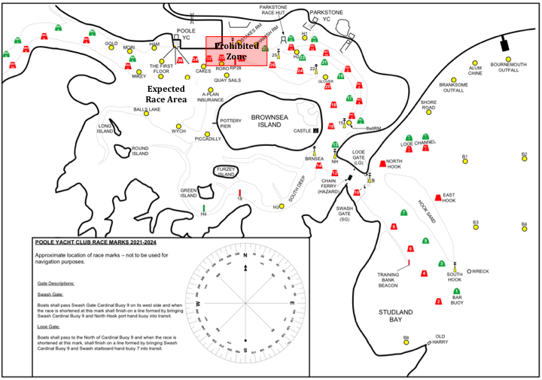

Addendum B – Courses
The diagram shows the course and the approximate relative position of the marks of the course:

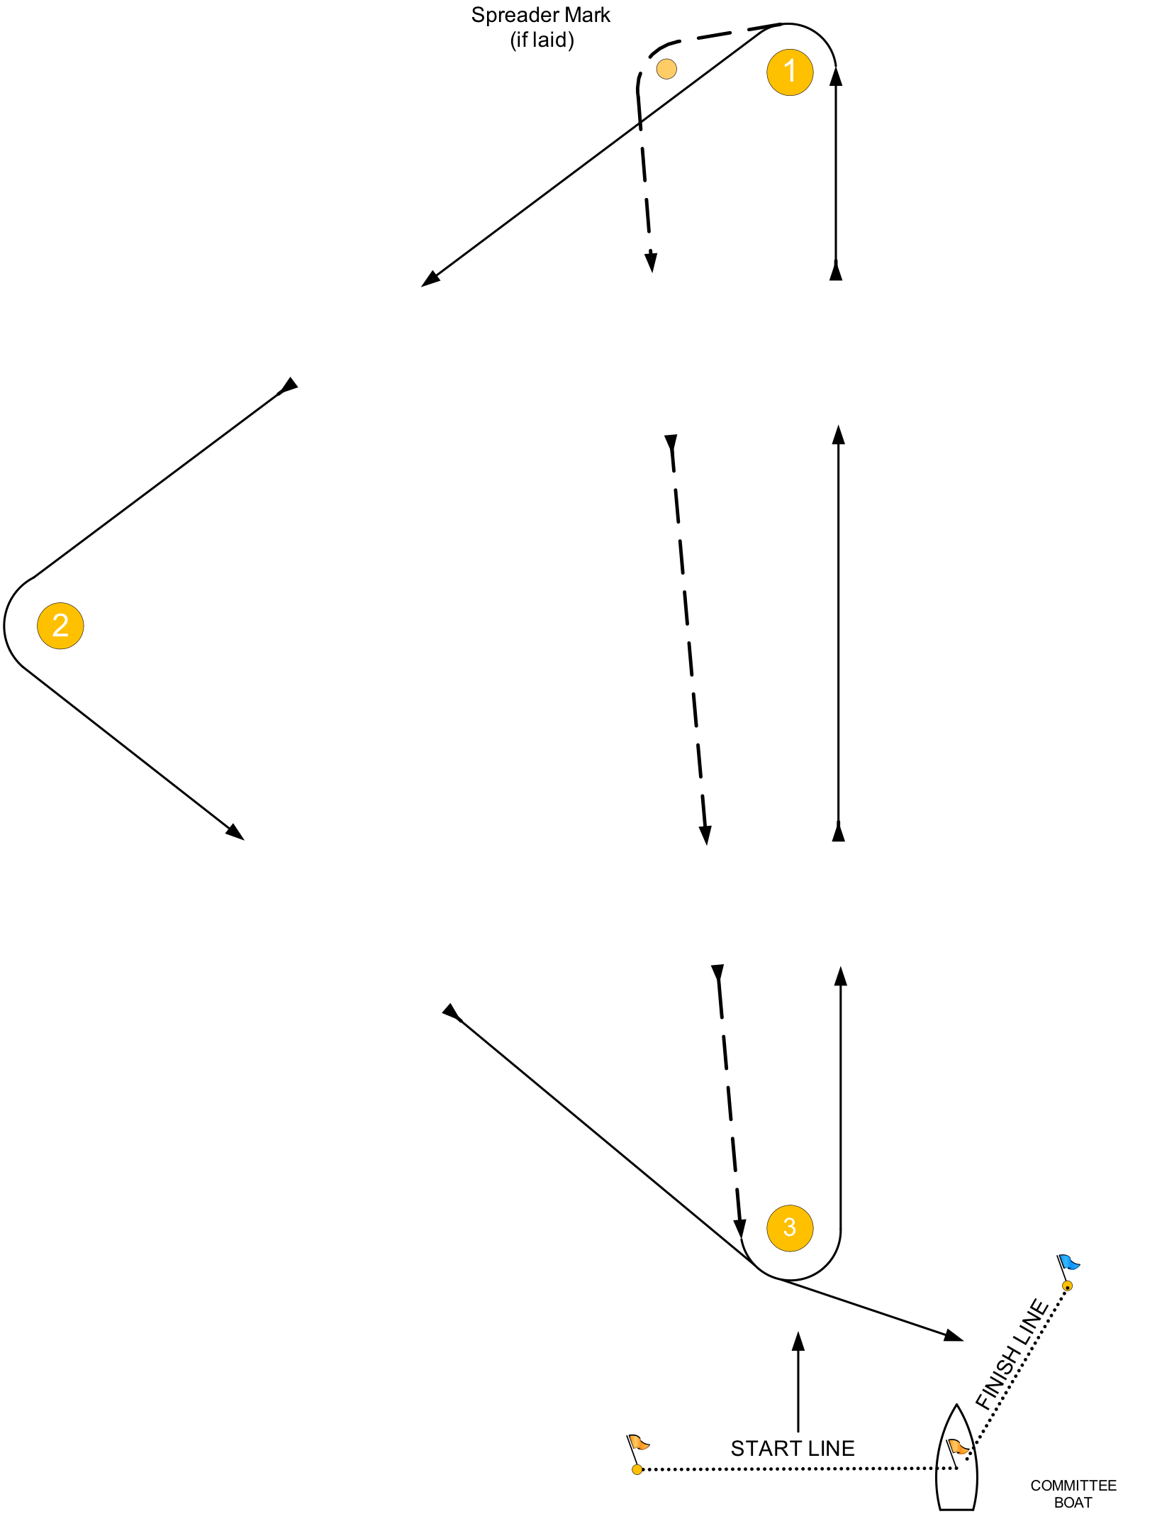
All marks of the course shall be left to PORT.
- LAPS = T2: START – 1 – 2 – 3 – 1 – 3 – FINISH
L2: START – 1 – 3 – 1 – 3 – FINISH
- LAPS = T3: START – 1 – 2 – 3 – 1 – 3 – 1 – 2 – 3 – FINISH
L3: START – 1 – 3 – 1 – 3 – 1 – 3 – FINISH
- LAPS = T4: START – 1 – 2 – 3 – 1 – 3 – 1 – 2 – 3 – 1 – 3 – FINISH
L4: START – 1 – 3 – 1 – 3 – 1 – 3 – 1 – 3 – FINISH
- If spreader mark is laid it shall be left to port on leg 1-3

